

**Group Members :** **Khuda Dad Saleem(231459091)**

**Fazal Dad Saleem (231459090)**

**Huzaifa Khaliq (231459085)**

**Course Name : Technology Management**

**Instructor Name : Saad Bin Saleem**

**Assignment # 2**

**Creating an Application**

Tool that we have used is **Trello.**

**Inviting other Members**

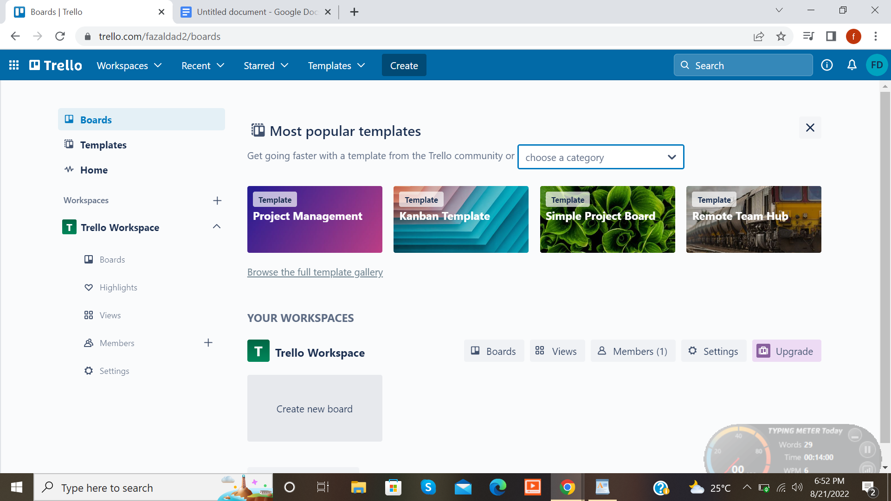

* Click on plus on left side label members.

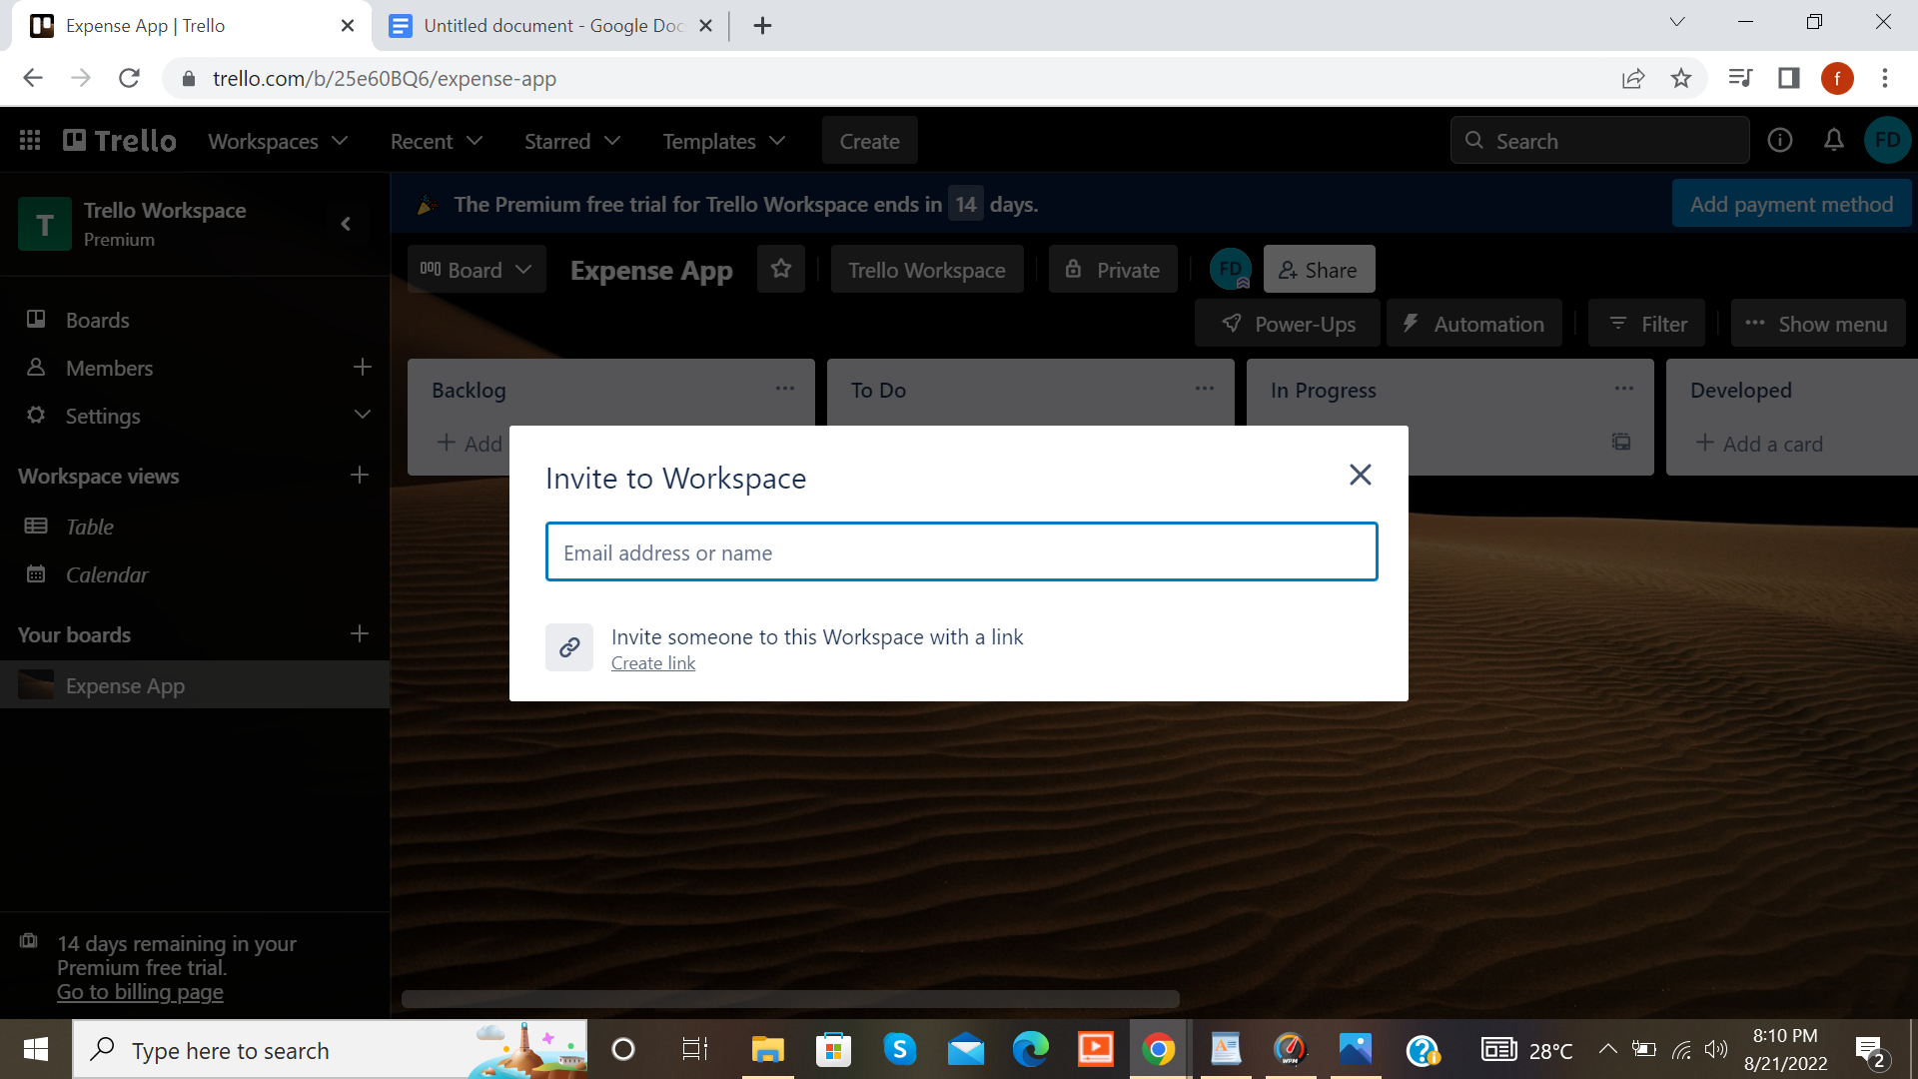

* Write emails of the members you want to invite.

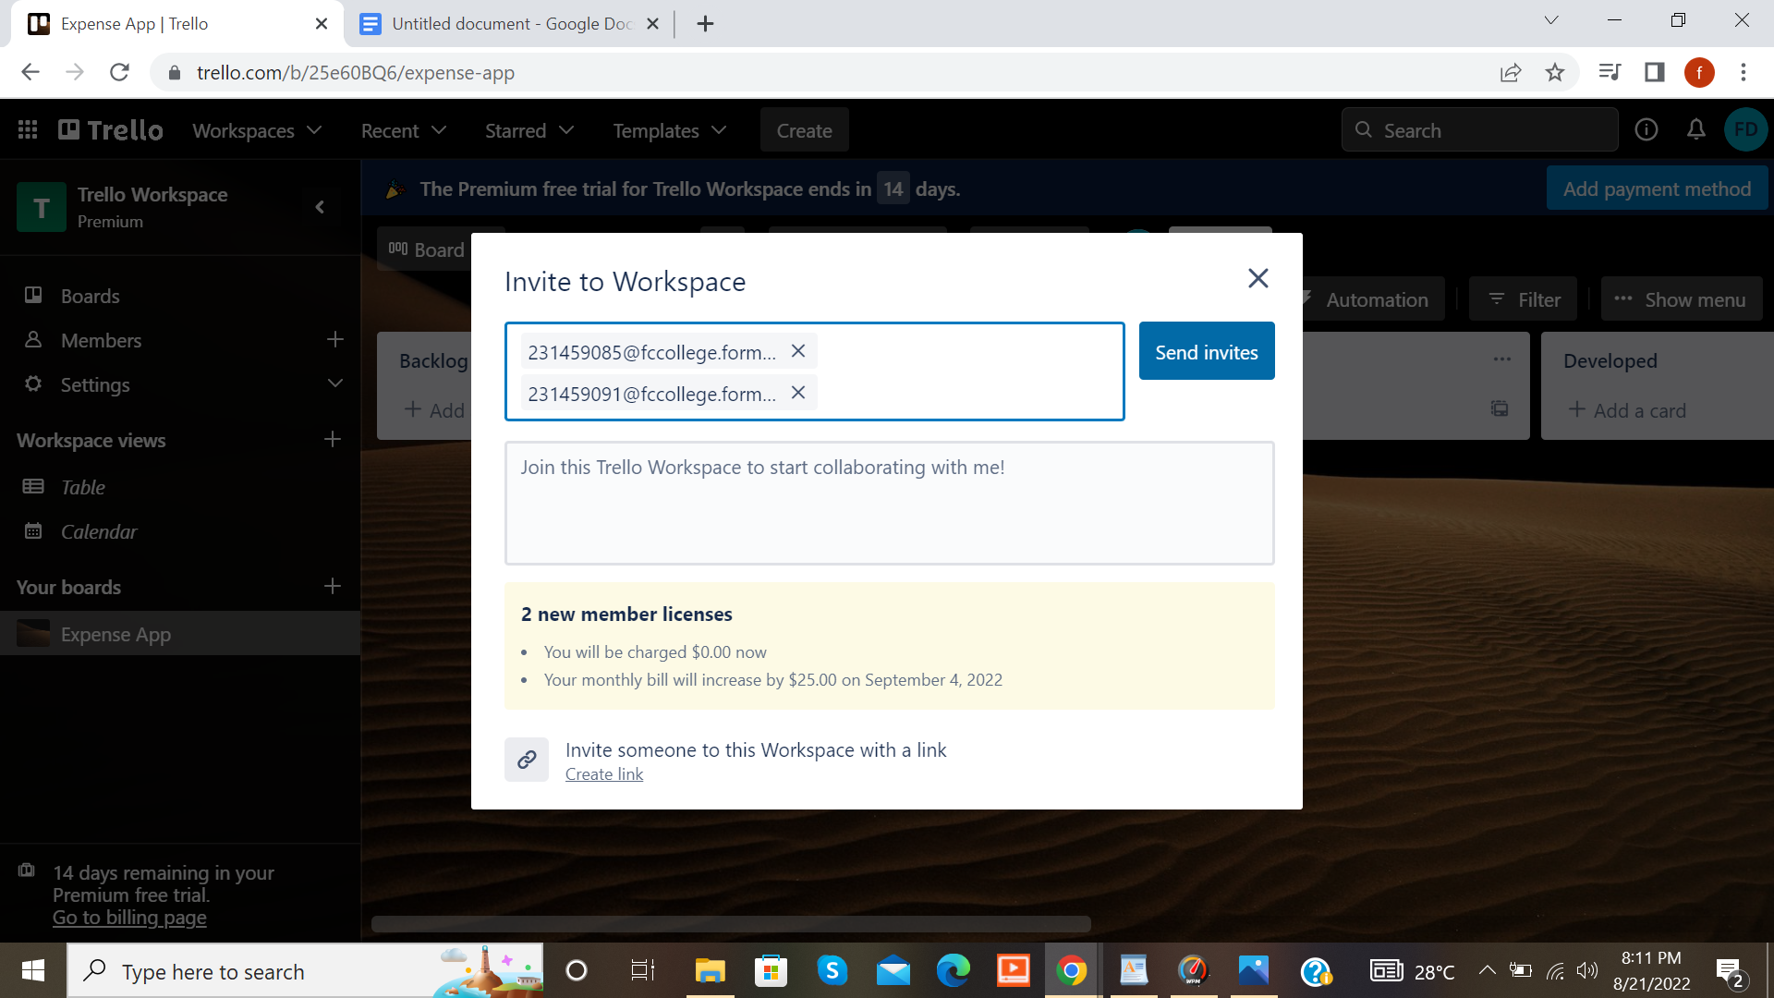

**Practice 1 : Creating a Board**

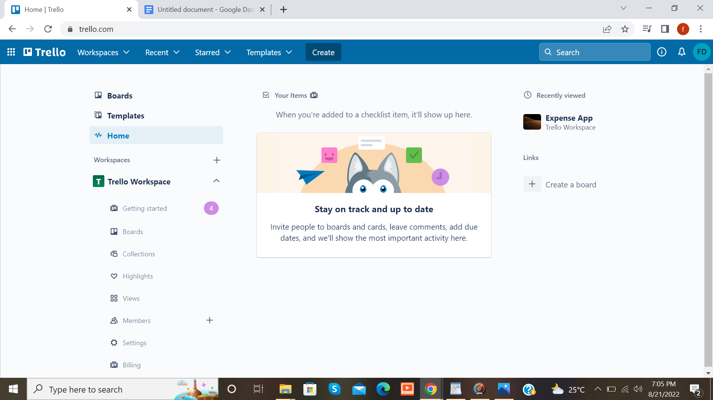

* Click on the board

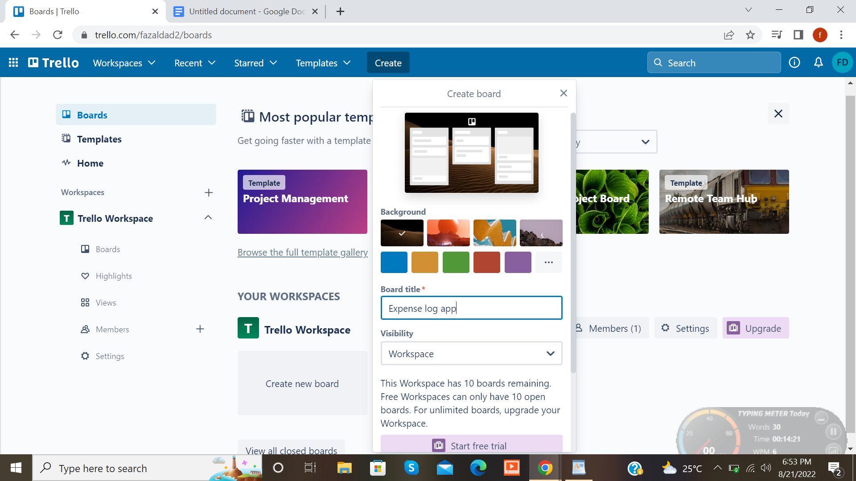

* We will write a board title “Expense Log”.

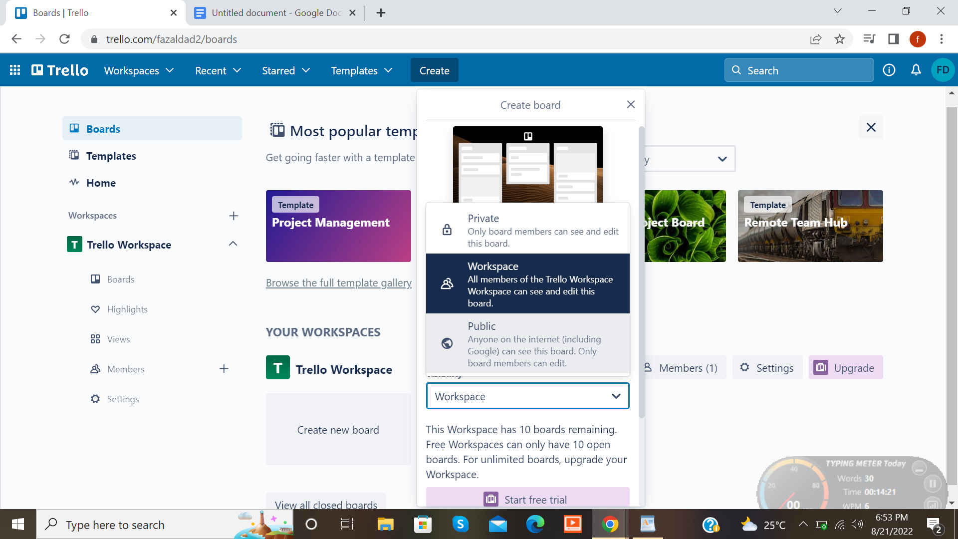

* Now we can select a team and We can make it private or public. I will keep it public so that our customers can access the application.

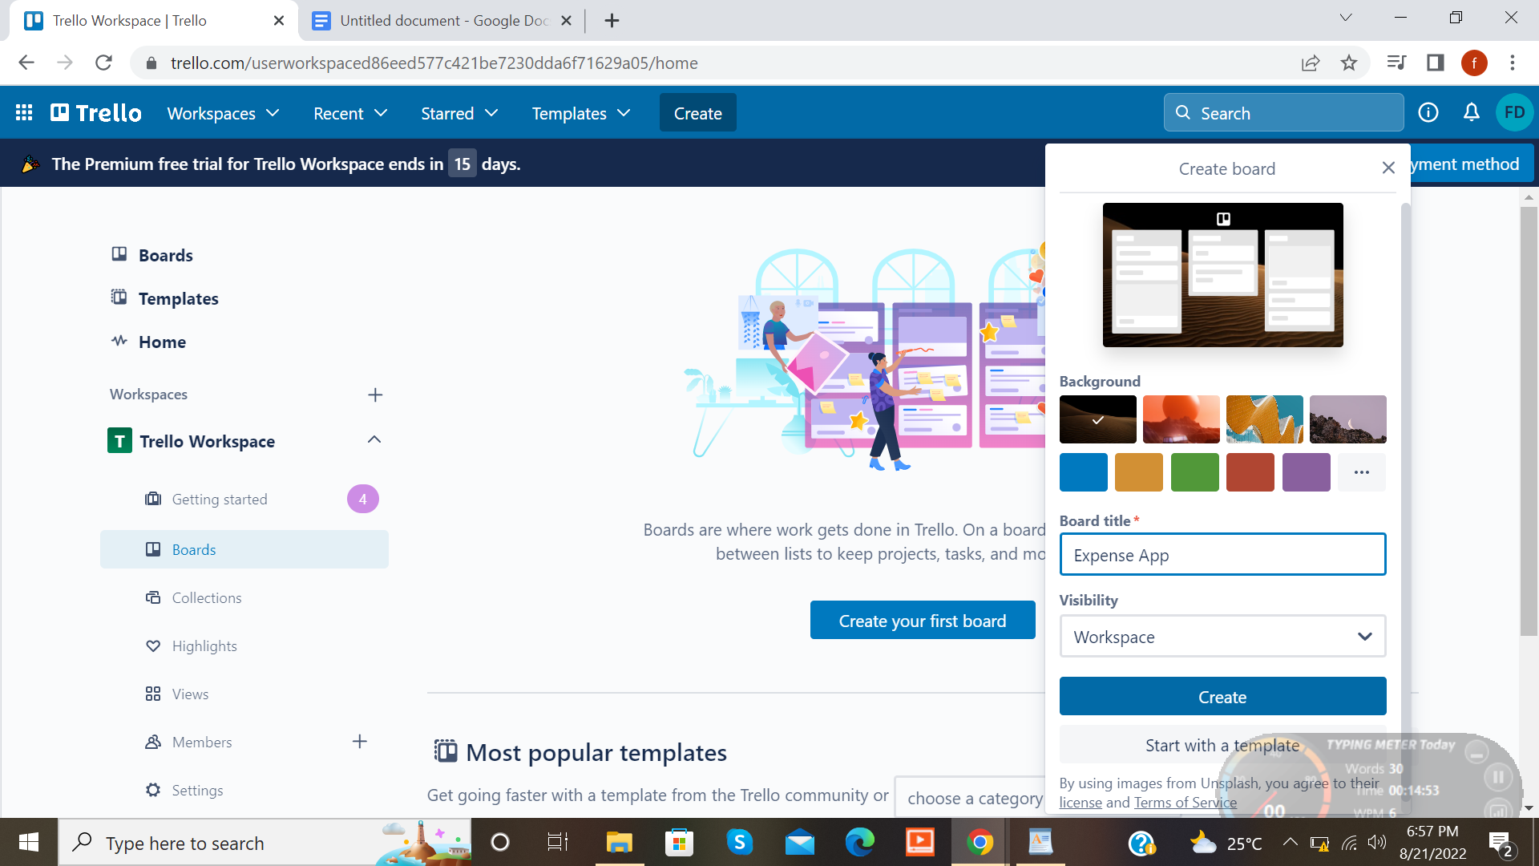

* Click on the create button and board is created with the name of “Expense log”

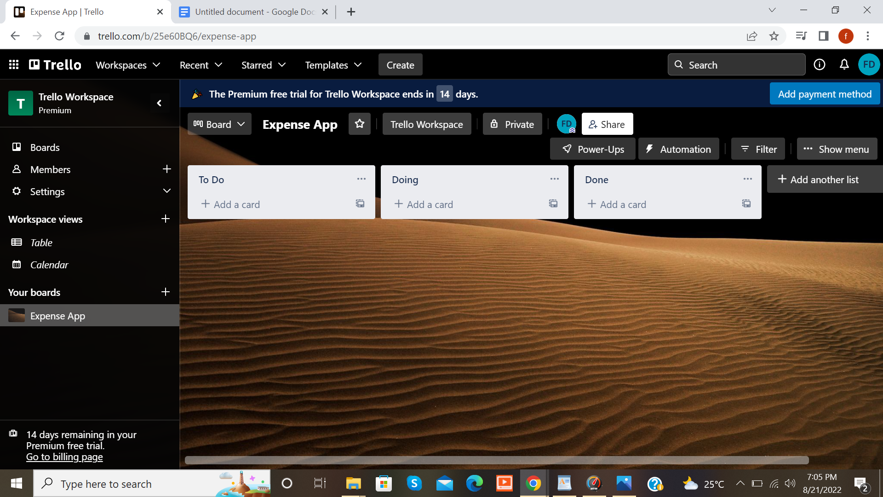

* Now this shows that board is created and now we can add lists and cards.

**PRACTICE 2 : Adding cards and lists**

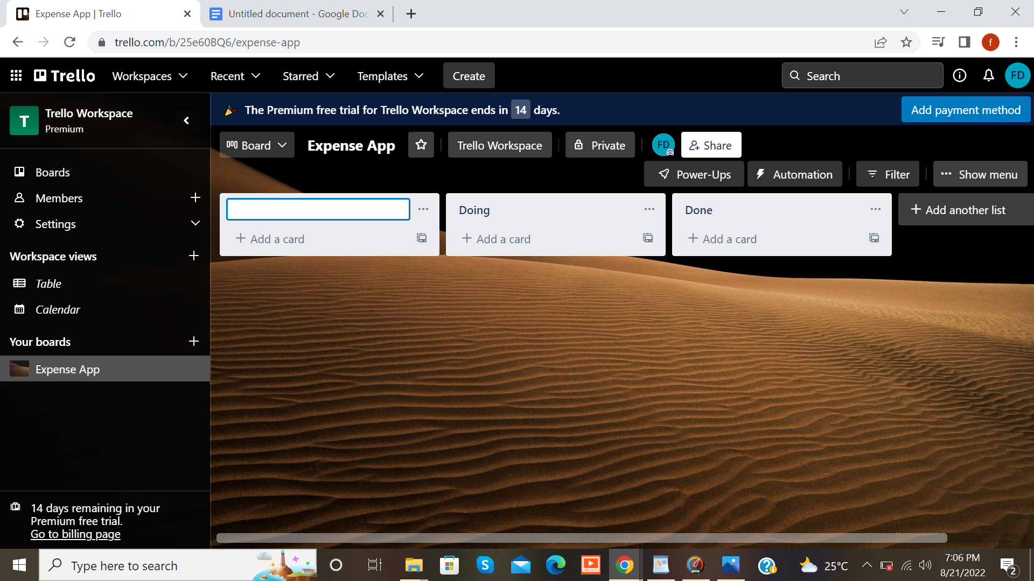

* Now here we will customize the board for software development.

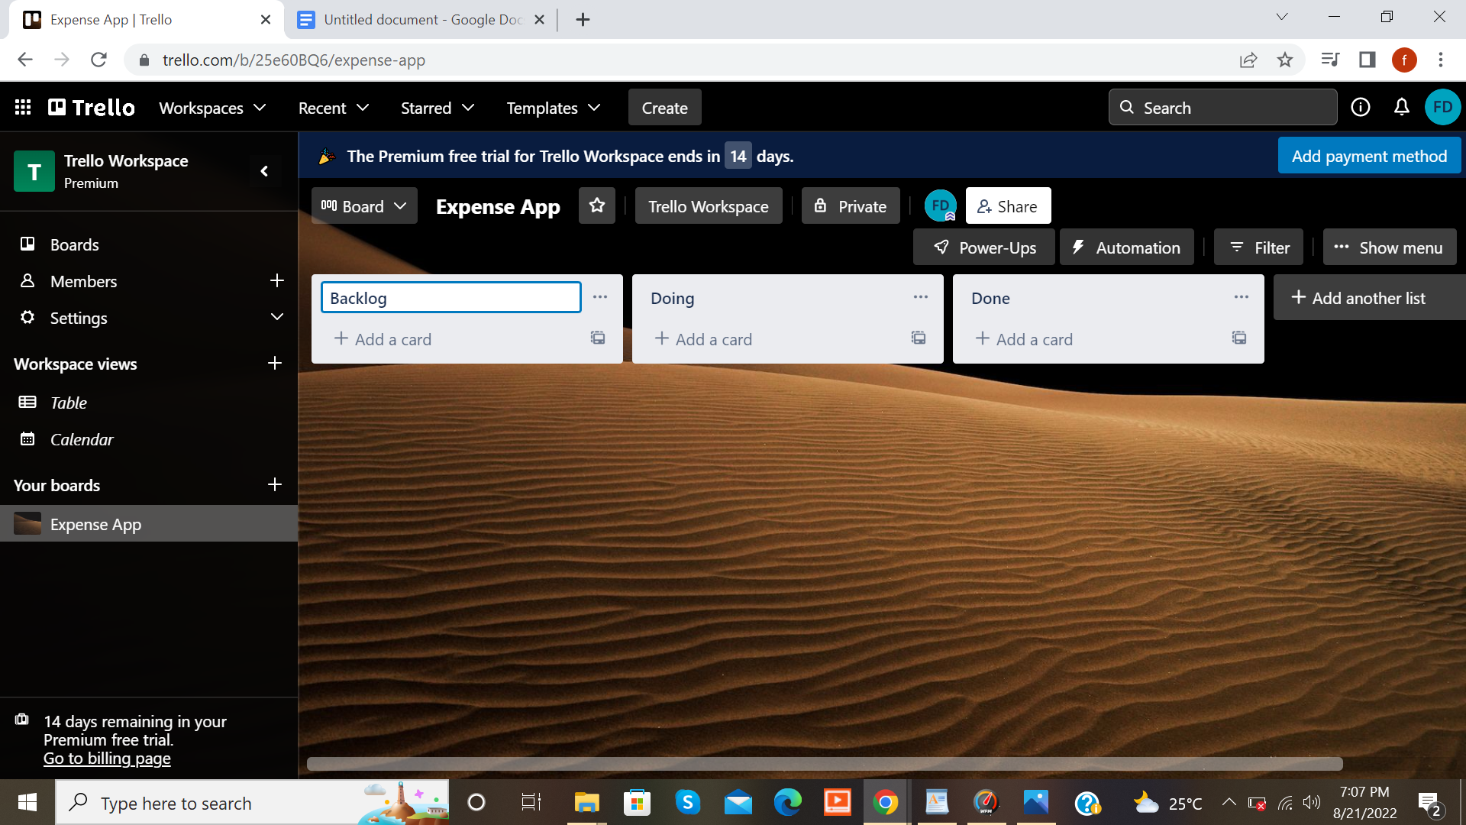

* Here we have created some life cycles. We have created lists and have given the name or title to every list. For example, the title of the first list is backlog. Backlog is a place where we will write all our stories. For example, If i have to add a register or login system in my app then we will write it in backlog.

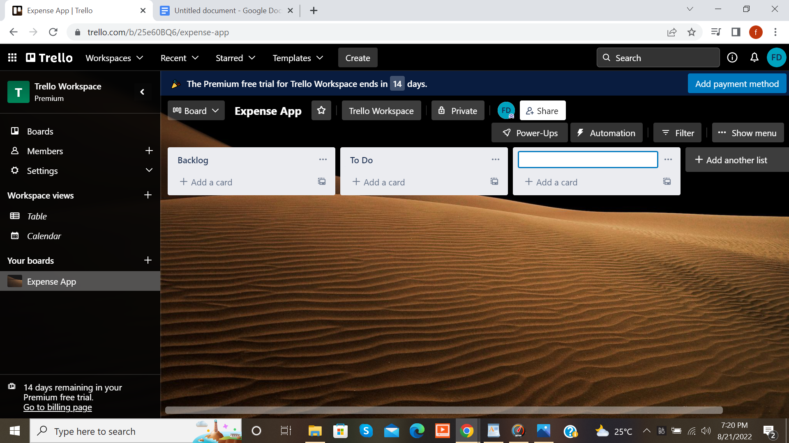

* The next lifecycle is **To Do.** the stories we have written in the backlog we can drag it to the To Do lifecycle.

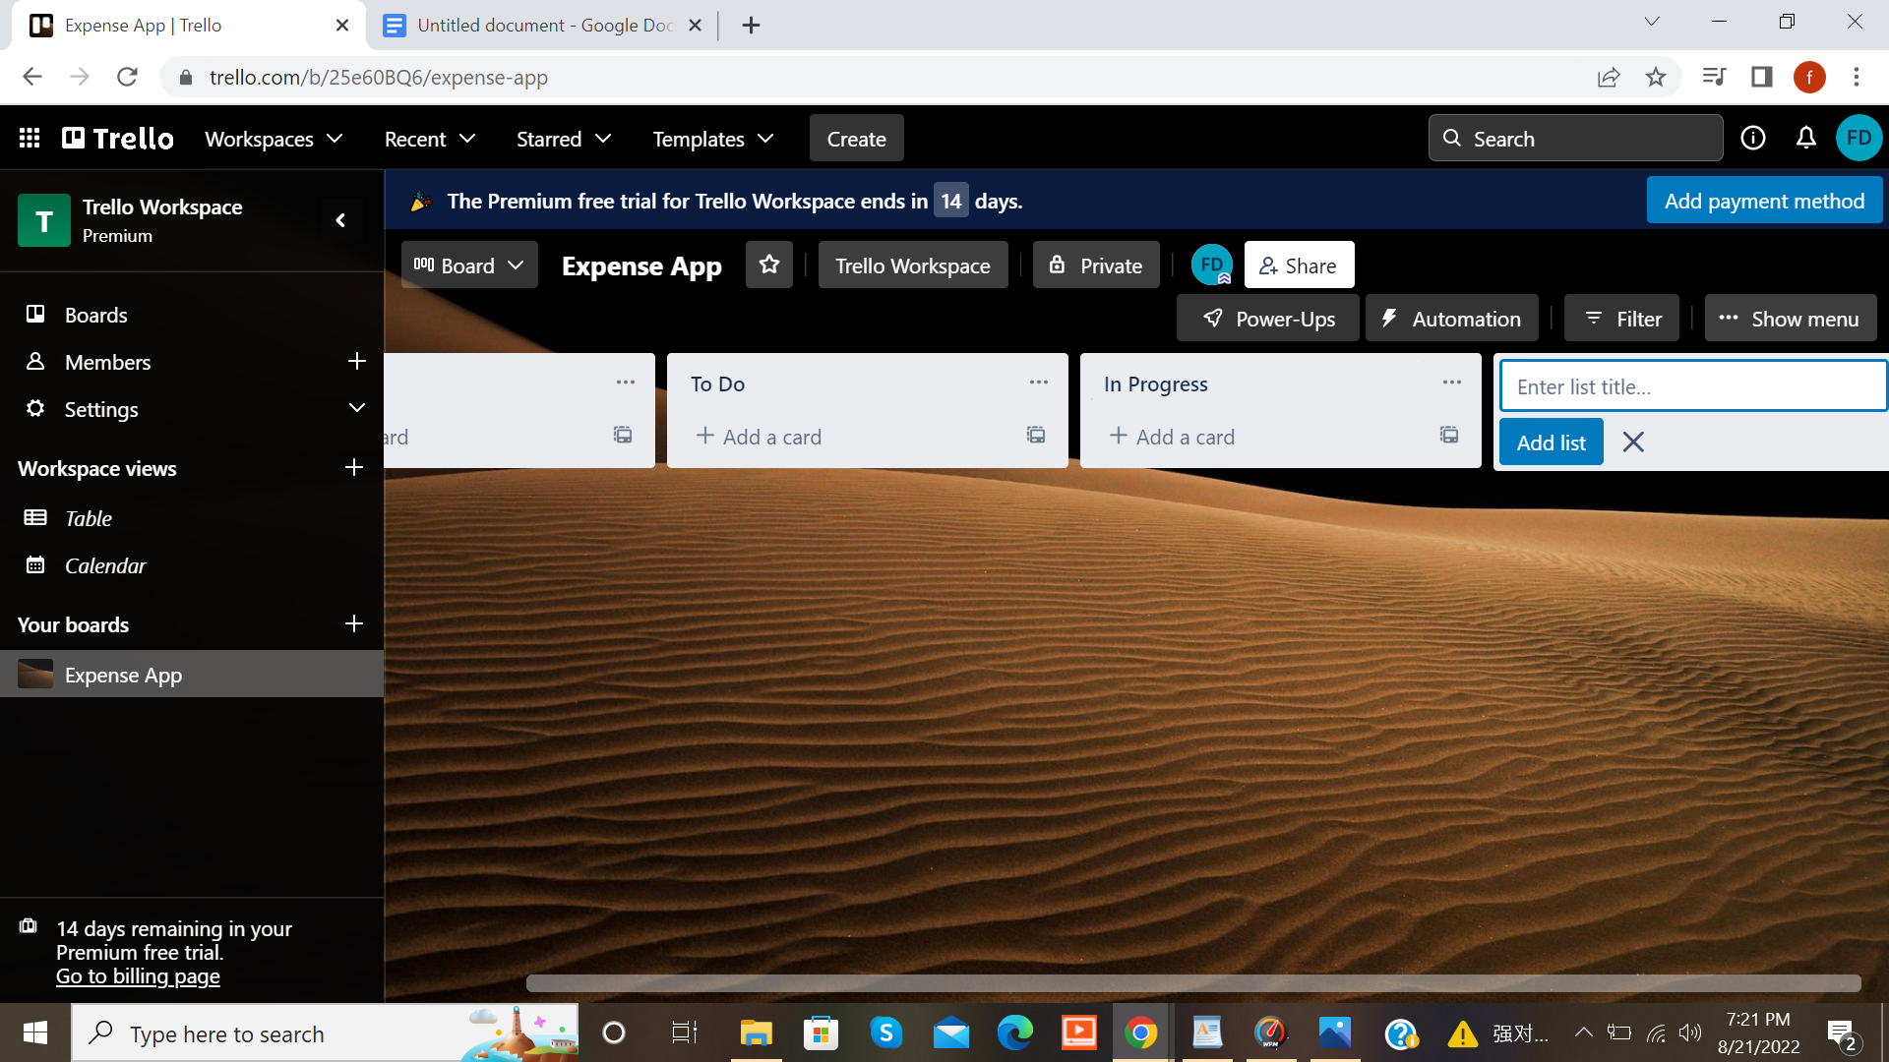

* The next developing lifecycle is **Progress.** So I know whatever I am working on that card would be in Progress.

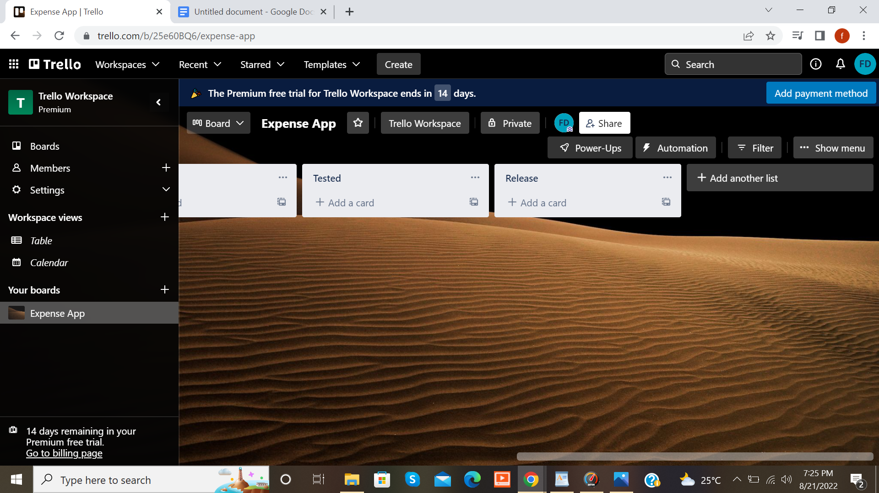

* The next lifecycle is **Tested.** If i want to test the feature that i have develop we will put it in the Tested.
* The last list is **Release**.

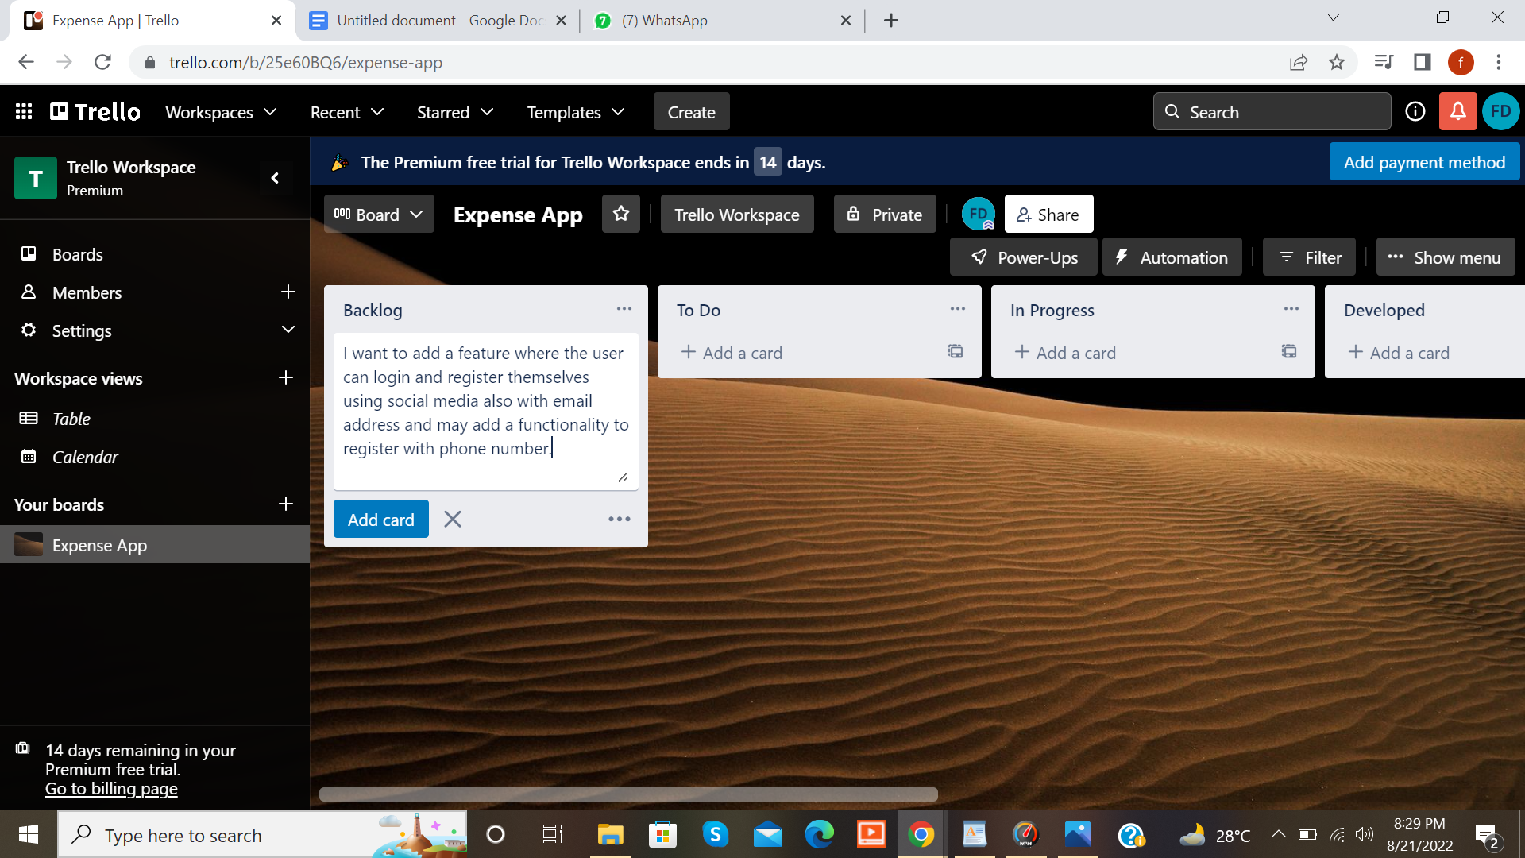

* We will click on this backlog card and write the information.

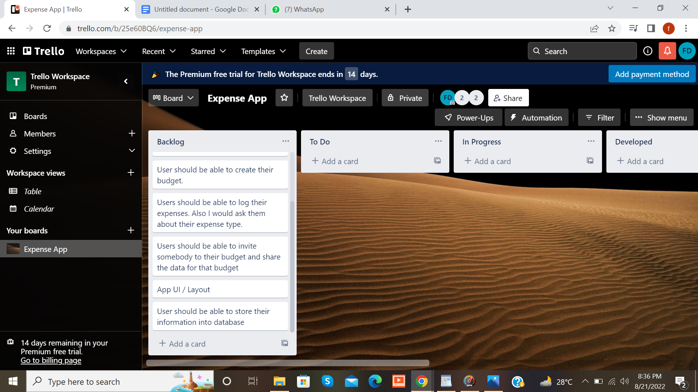

* We will write all the features in the Backlog which we want to add in our application as shown in the screenshot above.
* We can click on app UI/Layout to add description.

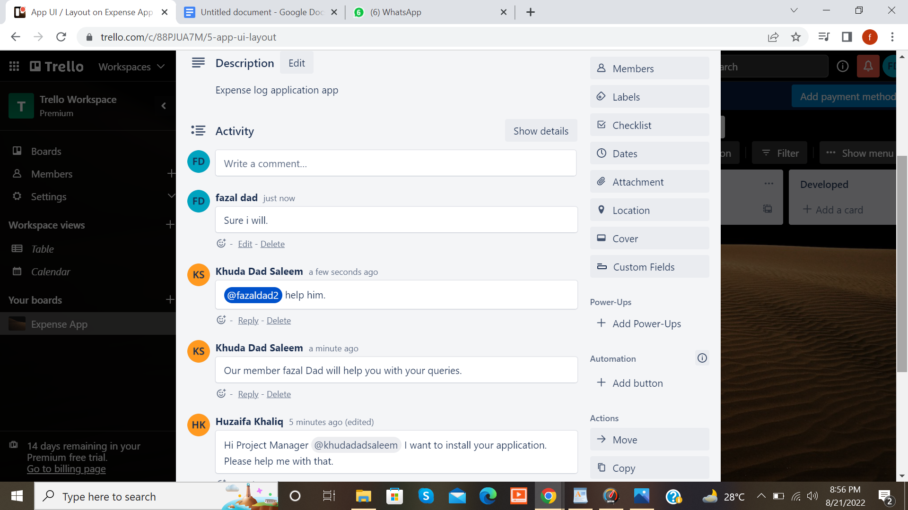

* By clicking on the stories in the card we can add a description of that story and can chat with other team members and customers.

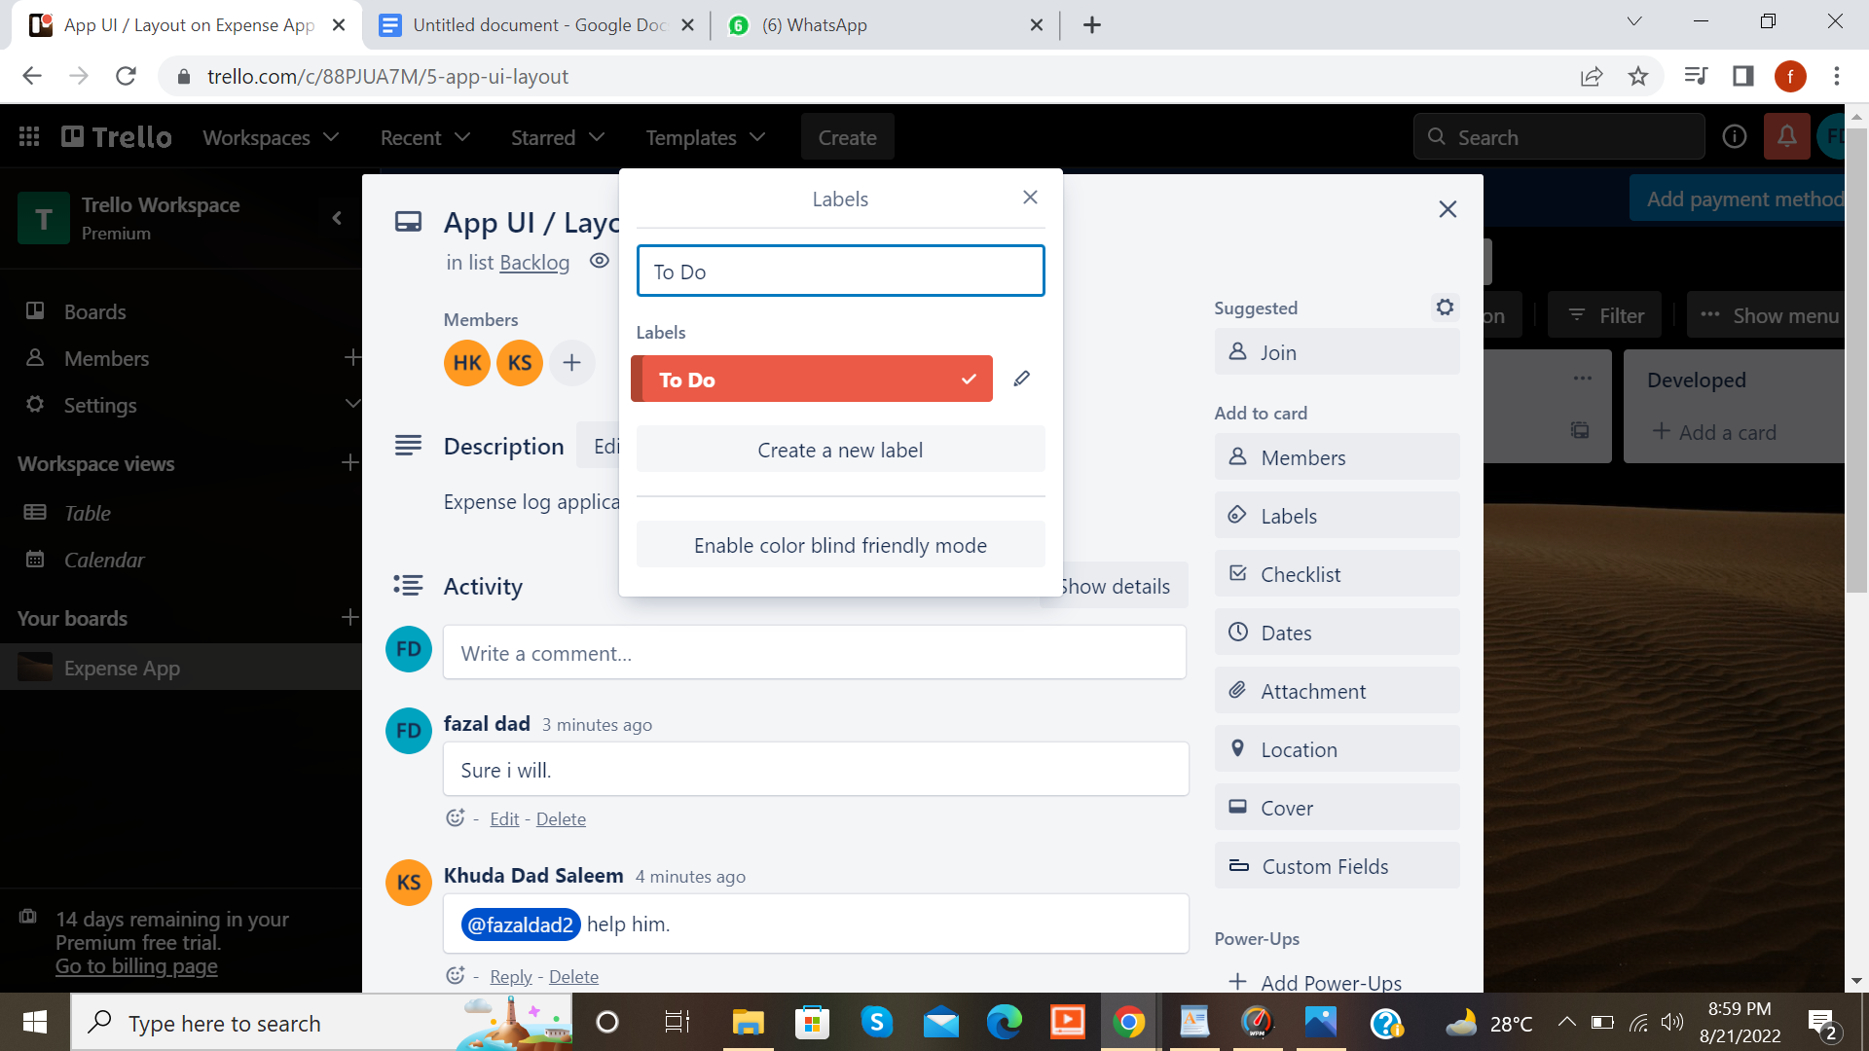

* We can also give labels to stories and can also highlight them with colours.

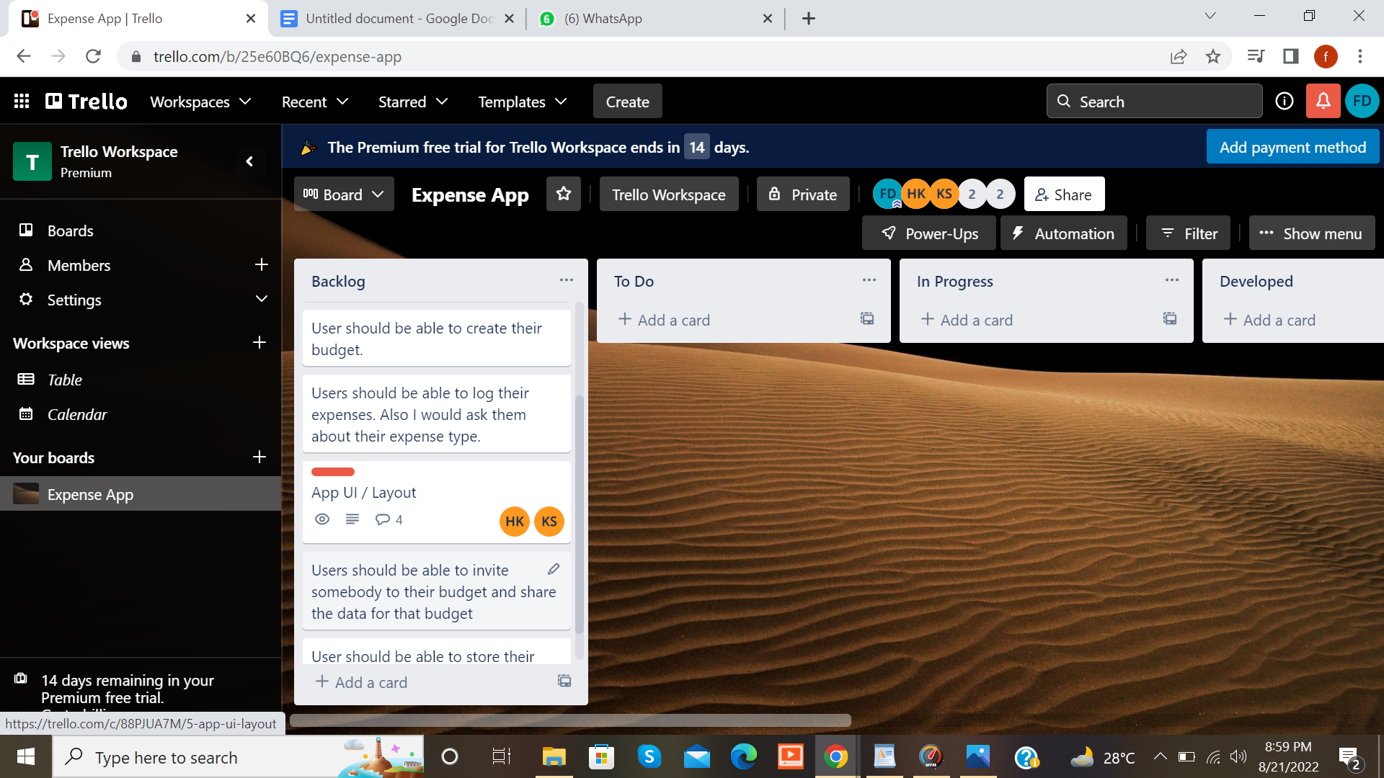

* If we think we are done with the information of a functionality we will drag it to the next card.

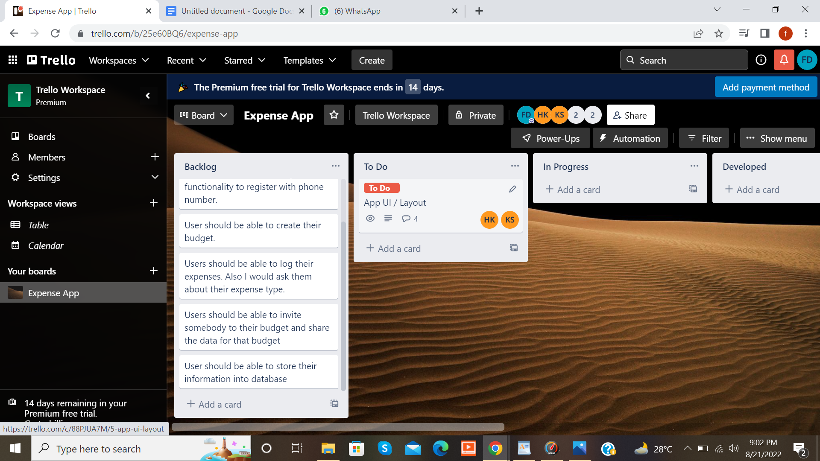

* We have to drag App UI/Layout to the card To Do.

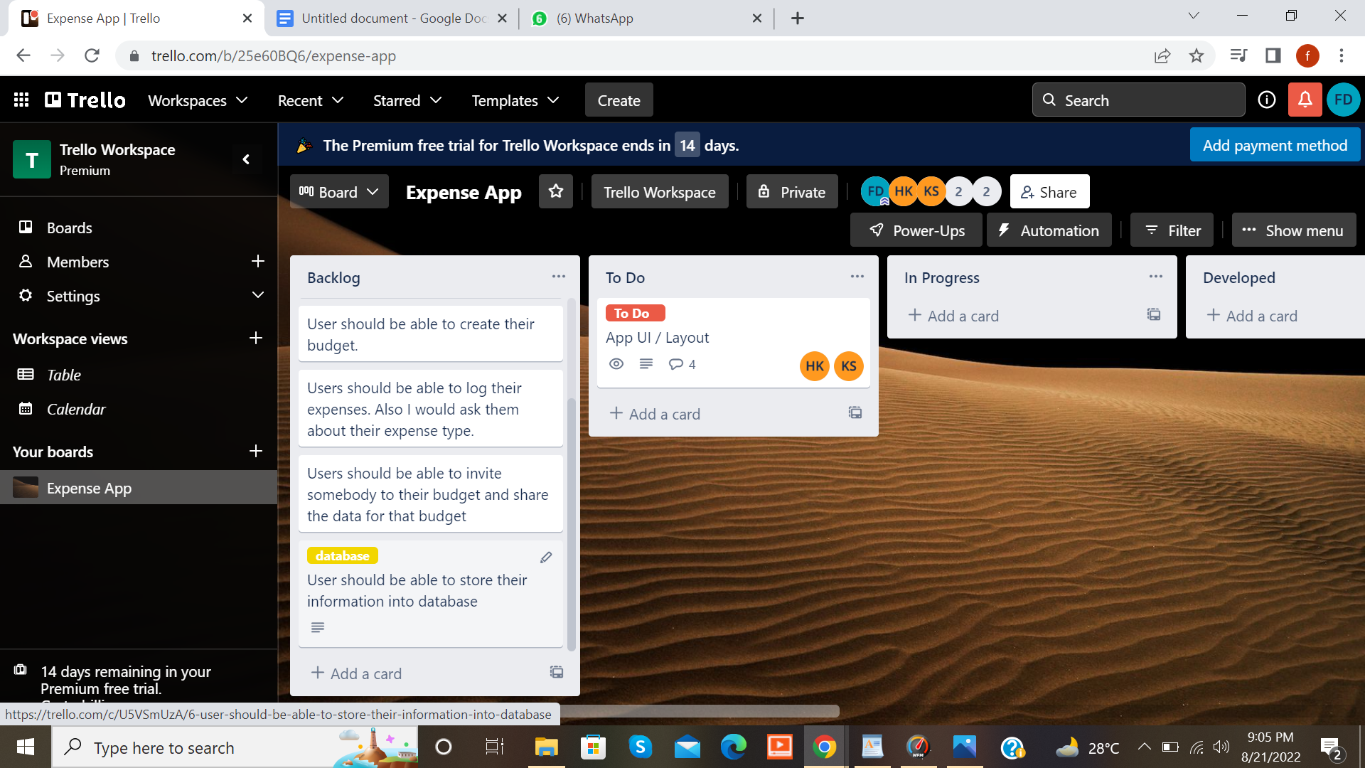

* We will label information in the other stories as well.

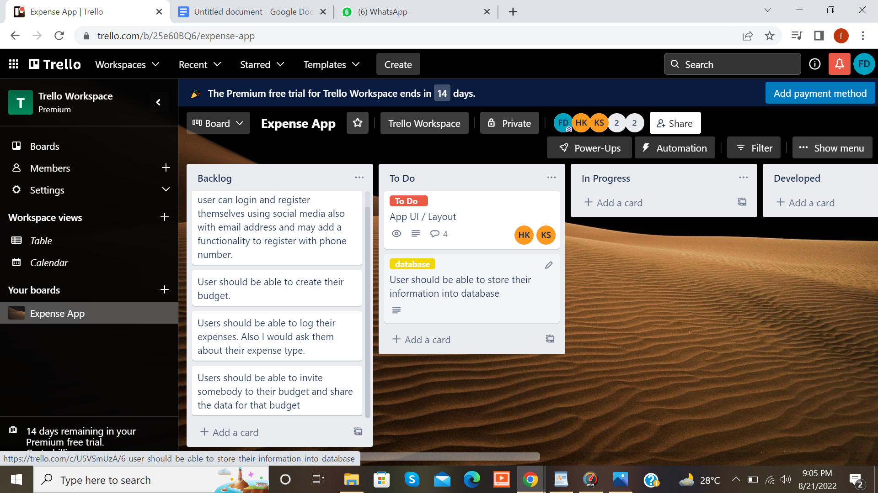

* The story base data base in the card TO Do will drag to the next card.
* Story labelled database is dragged to the card Progress. Basically it detects the work. It allows you to know where your work is reached. 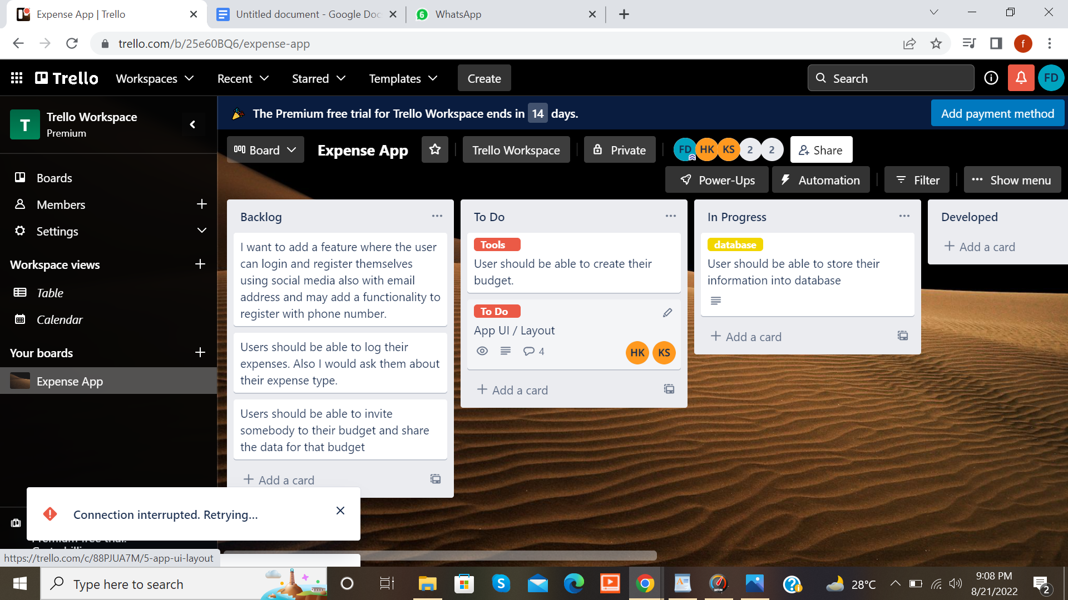

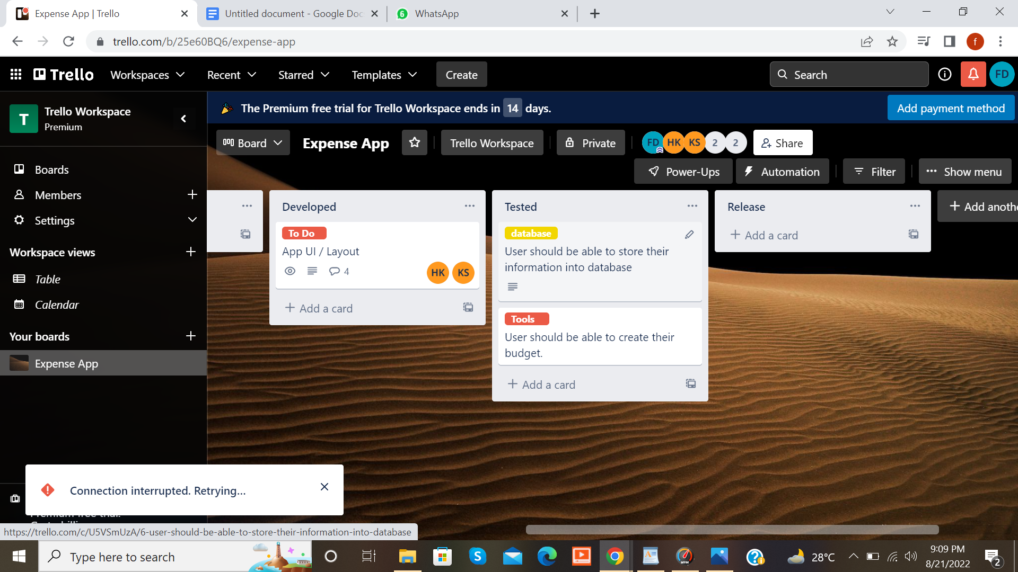

* The story labelled To Do is also dragged to the card Progress.

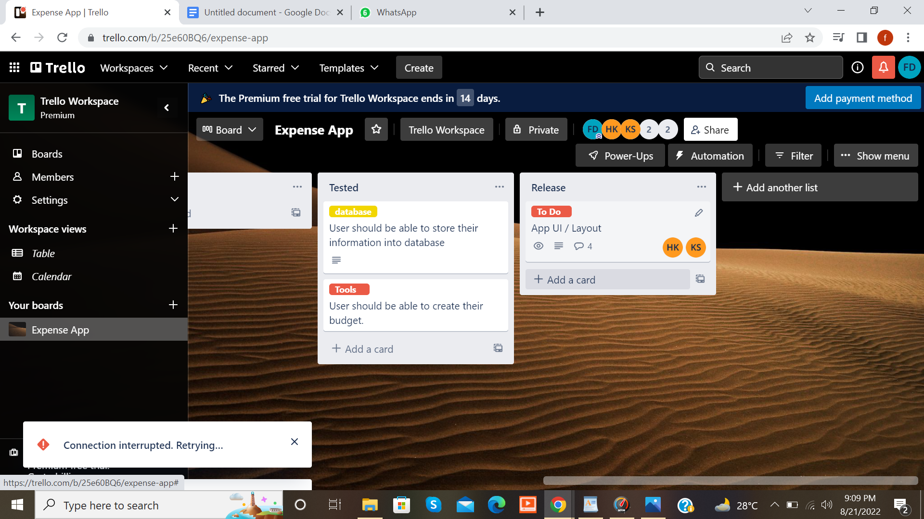

* Once the feature has been developed it is dragged to the next lifecycle Tested. So that features could be Tested.
* Once it is Tested it is dragged to the next lifecycle Release.